|  |
| --- |
| **rmp software solutions** |
| External Game Document |
| **[Assignment 01]** |
| Version #XX  All work Copyright © 2012 by XX Games.  All rights reserved. |
| **RUKSHAR PATEL** |
|  |

|  |
| --- |
| May 19th 2012 |

**Table of Contents**

**Version History**

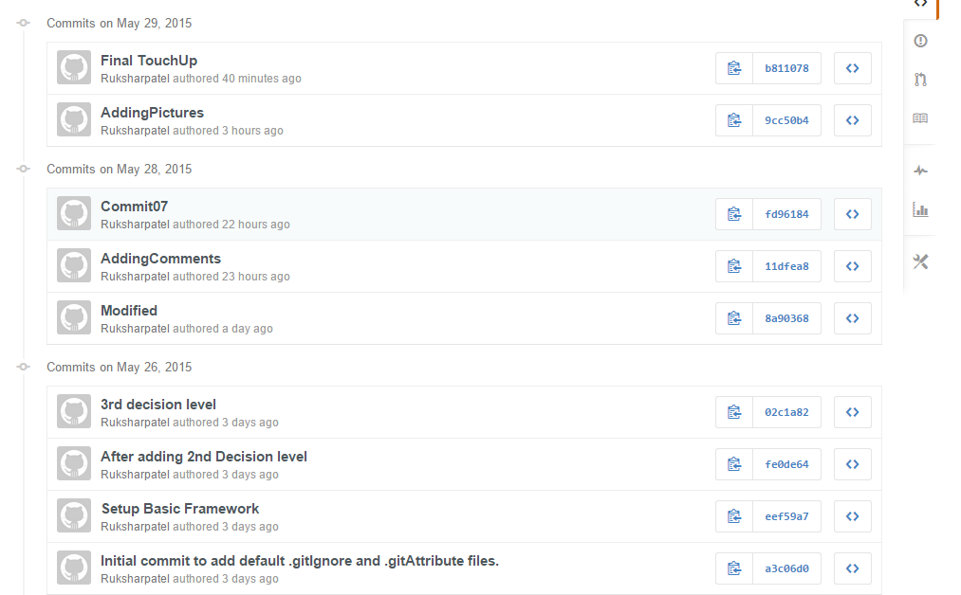

***Link to GitHub***: https://github.com/Ruksharpatel

1. **Game Overview**

*Tunnel Maze Game is the game where Player explores the tunnel throughout the game while following the rabbit. It allows the user to explore the tunnel behind the Doors. The Game starts with the user following a rabbit and falling down in a deep dark tunnel where he comes across different items and devils. The user has to decide which person to choose best so as to find the rabbit and a way back to home. Ultimately, the goal of the user is to find the rabbit and a way back to home as he is unconsciously lost because of falling down in the tunnel. The game has different levels and a Key which will help user to open the doors to explore the tunnel more in order to find the rabbit.*

1. **Levels**

*Tunnel Maze has 3 decision levels. The first level takes the user to the big hall way, where he found himself in the room full of doors.TO move further, a Key needs to be chosen. To open the door, the keys are provided in the first decision level where one key to the door will give user a chance to enter more into the tunnel where the other door will take the user to the path ways where one path will take towards the user to big doors, whereas second path will take him to the small door which is second decision level for the player. Similarly, choosing Golden Key, and opening the door will give user a two stair cases where one will give them a beautiful lovely Garden and other will be exploring the door from inside where they encounters two strangers which is the last decision level for a player to trust either of the person infront of them and ask for help. One stranger will help the player find the way while other will refuse it or kill it or tied them.*

1. **Characters**

*Like eight outcomes there are eight characters in the game. Every time the player clears the second decision level, he comes across two characters where choosing one will make the player lose the game where as the second will help find a way out. The characters are more likely to be attractive which makes harder for user to choose one of the character. The character in the games are Red Queen, Blue Caterpillar, Hat Man, 3-legged Man, White Persian Cat, Dodo Duck, Twin Brothers and White Queen.*

*The main Character is the rabbit who is being chased by player and gets lost in the tunnel. Therefore, the player has to find the rabbit and also a way back to home.*

1. **Item**

*The game provides player with two keys to open the doors to explore the tunnel more and chase the rabbit. The two keys provided as hint for the player to open the doors and move to next level.*

*The two keys are Silver Key and Golden Key.*

1. **Cheat Codes**

*Among the eight characters, White queen turns out to be positive for the player who not only helps the player to find the rabbit but also a way to its home. The player comes across the white queen at 3rd decision level if he chooses the golden key and Modular Staircase at decision level 1 and 2 respectively.*

1. **Notes**

*After moving forward from the 1st decision level, the user comes across the screen which says open. It does not allow users to choose the options but instead allows to reach to second decision level. The player cannot move forward unless the door is opened by selecting either a key.*

1. **Future Features**

*In Future, two more decision level can be added where while going back to home the player faces a Mad Hatter who is the owner of the rabbit and the player has to fight with the mad hatter using the weapons or give the rabbit back to the owner. If user chooses to fight with a weapon, it will include sword fight or protection from shield. Using, protection from shield will make player win and have the rabbit forever, while fighting with weapons will take the player to more complex levels.*